

**CIS 11051 – PRACTICAL FOR DATABASE DESIGN**

Information and communication Technology

Faculty of Technology

South Eastern University of Sri Lanka

Registration Number: SEU/IS/22/ICT/075

Academic year: 22/23

Lab Sheet 08

1. Create database

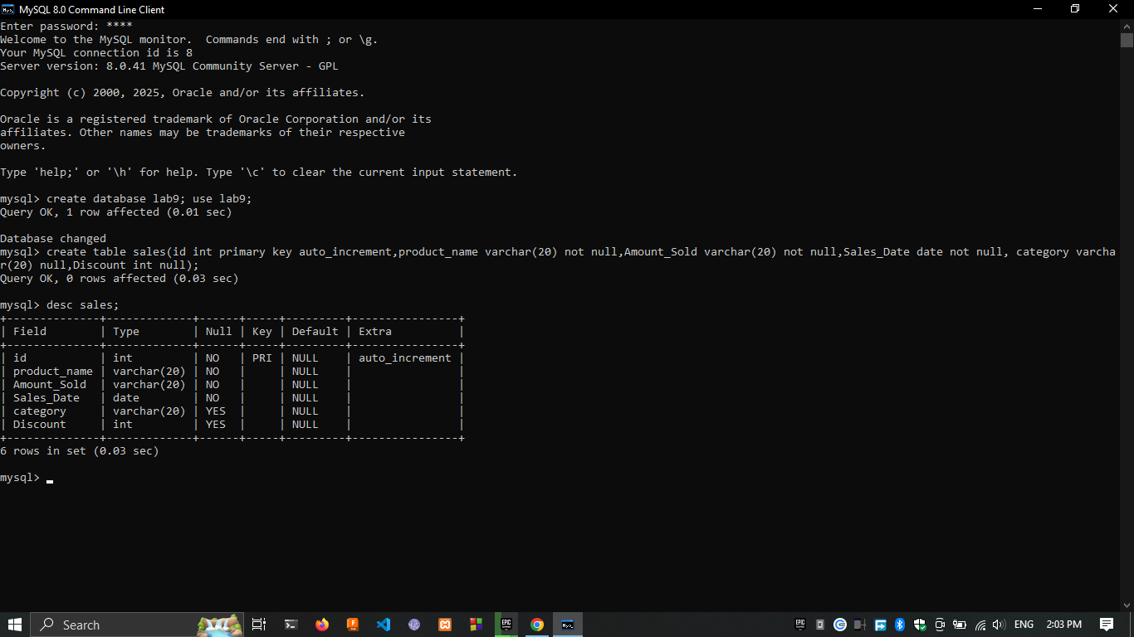

Create table

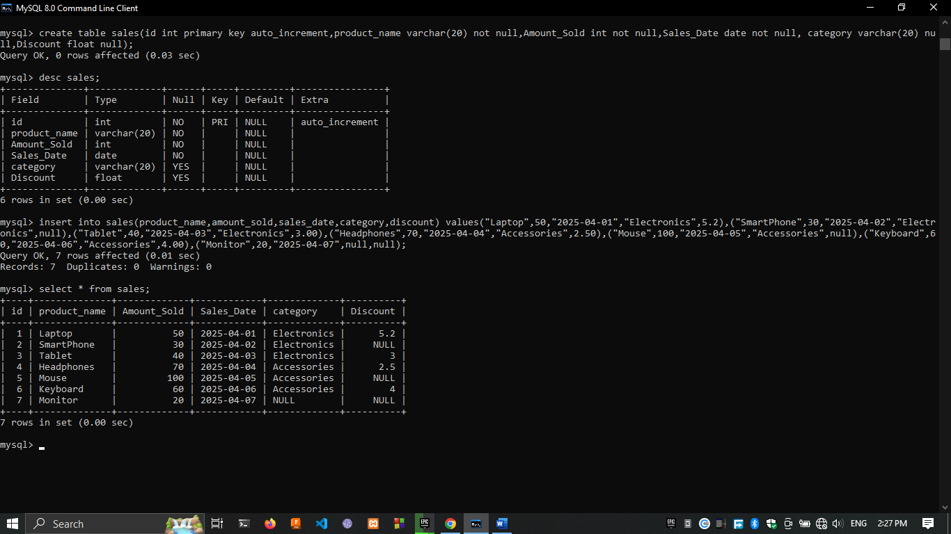

1. Inserting data



1. Sum of amount_sold

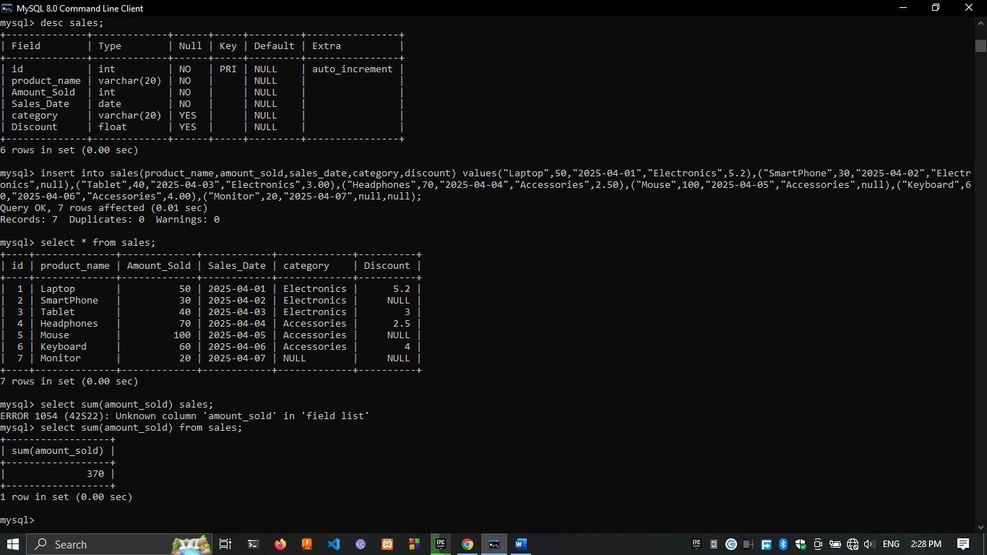

1. Average amount_sold

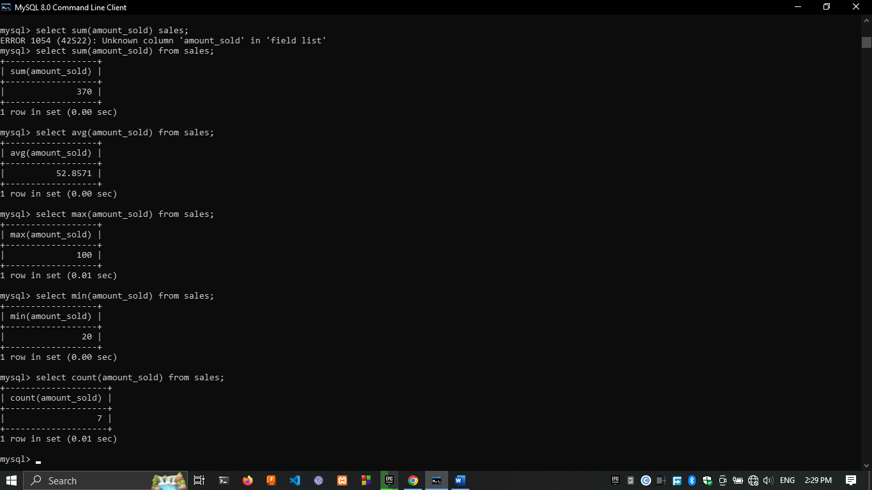

1. Maximum amount_sold



1. Minimum amound_sold



1. Total product sold



1. "Electronics" category that have sold more than 30 units.

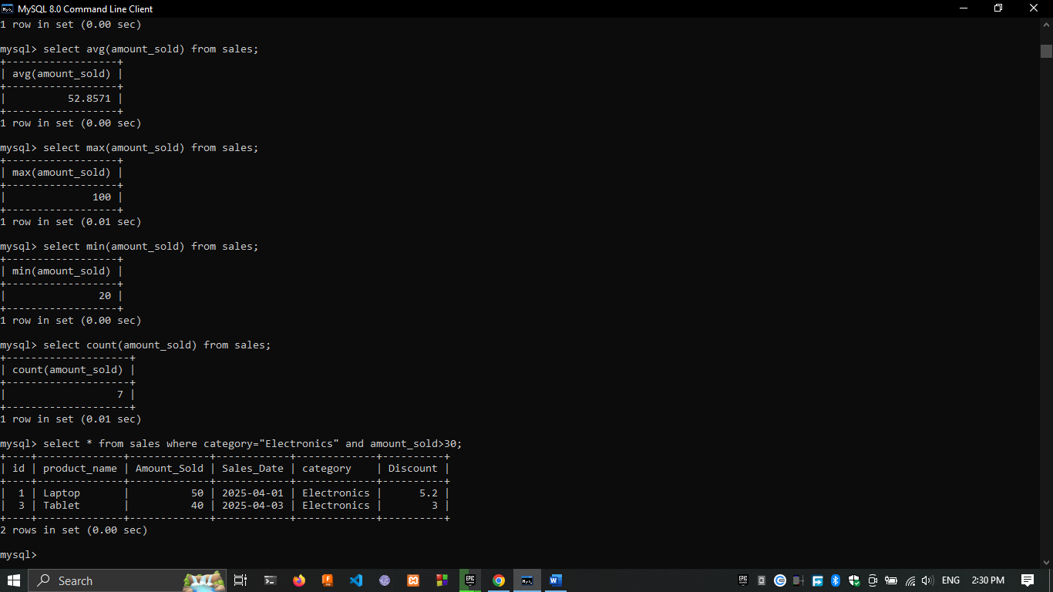

1. sales data by category and calculate the total sales for each category

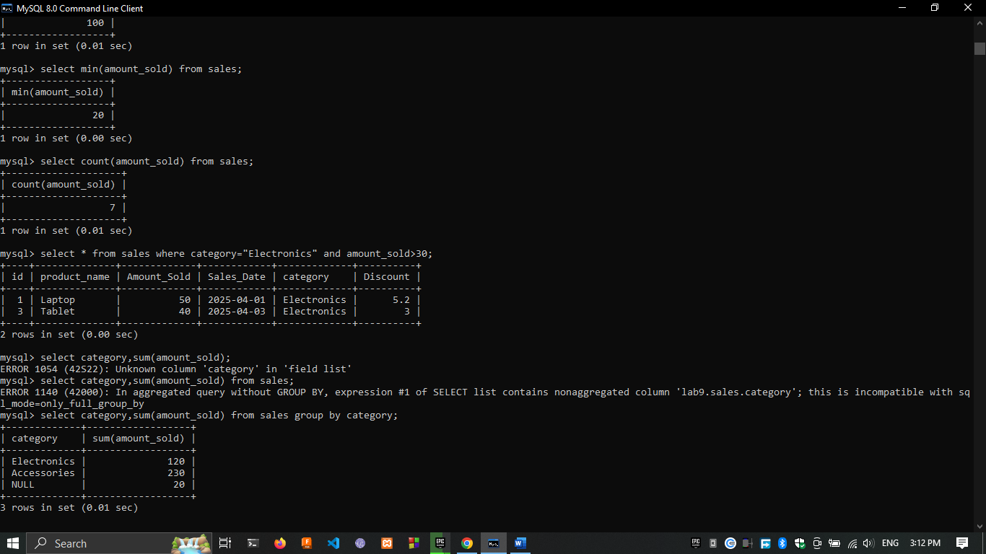

1. categories that have sold more than 100 units in total.

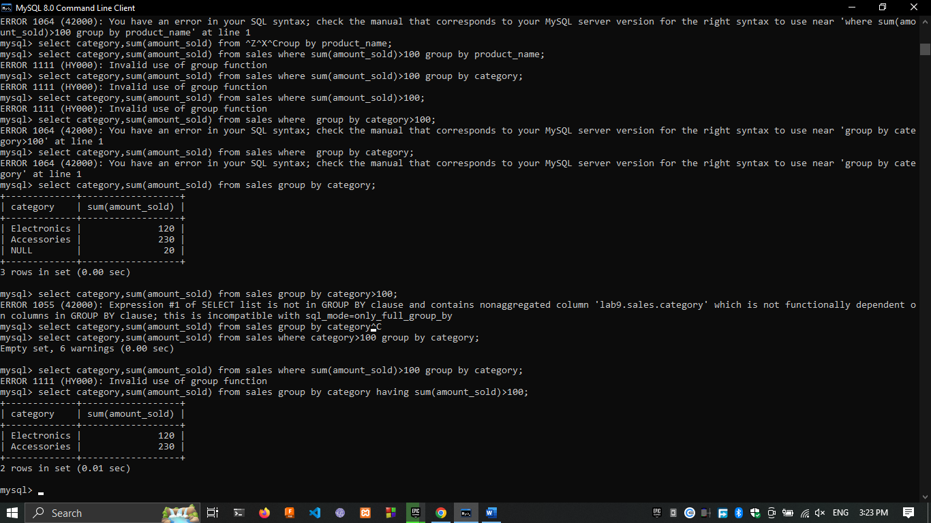

1. products sorted by amount_sold in descending order